Using CST or AnsysEM on the Forge Cluster Server

Forge server introduction: https://wiki.mst.edu/itrst/pub/forge

1. Setup a user account on the cluster
Submit a support ticket to IT online at http://it.mst.edu/. Request that they setup an account on the Forge CUDA cluster for your user ID. You will not be able to use the cluster until this is complete. You should get a confirmation email when they have setup your account.

2. Install Filezilla FTP client and be sure that PuTTY is installed on your computer.
Filezilla: https://filezilla-project.org/download.php?type=client
Putty: https://www.putty.org/
MobaXterm (Combine the putty and Filezilla): https://mobaxterm.mobatek.net/

3. Remote into the cluster’s FTP server
The model files must be transferred over to the cluster. The cluster is configured as an FTP server, and Filezilla allows us to easily access the cluster’s filesystem. Filezilla’s display is partitioned into a few segments, shown below.
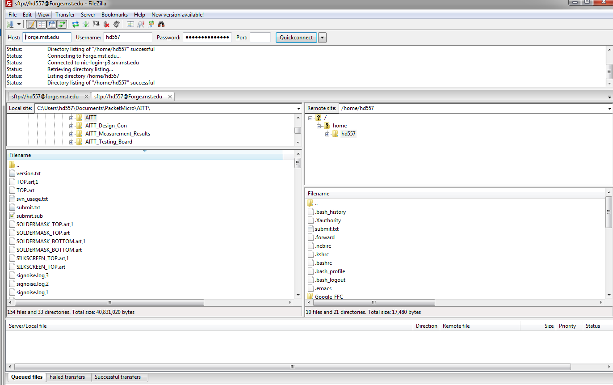
Filezilla GUI
Host: forge.mst.edu
Username: [Your user ID]
Password: [Your campus password]
Port: 22

Then Press Quickconnect.
If successful, you should see a listing of directories on the right hand side of the Filezilla window. These are contained in your personal Home directory on the cluster. It is recommended that you create a new CST directory on the cluster by right-clicking in the directory listing and clicking “Create directory.” You are welcome to organize your files however you wish, as CST does not care.
Copy the CST file over to the cluster by dragging it from your local machine to the server in Filezilla. The progress of the file copy will be shown in the lower region of the Filezilla window, which will clear once the copy is complete. The CST filename cannot include spaces.

4. SSH into the cluster using PuTTY
The Linux CST solvers can only be run through the command line. Therefore, it is necessary to gain remote access to the cluster through SSH. Open PuTTY and recreate the settings shown below. We are logging into the same nic.mst.edu server on port 22 as we did through Filezilla. You do not have to enter your user ID or password yet.

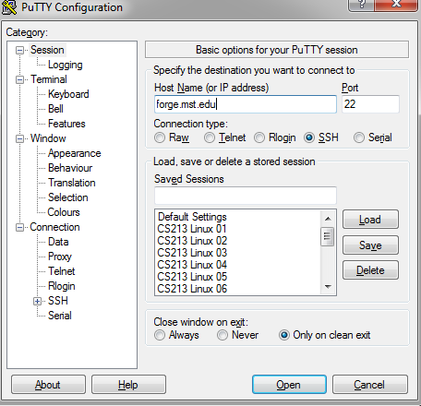
Putty GUI
Press “Open”. If successful, you will be greeted with a terminal prompt asking for your user ID. Enter your ID and press enter. You will then be asked for your password. Enter that as well. Note that in Linux, your password will not be visible as you type. This is normal. You should now see a display similar to that shown below.

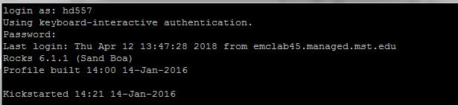
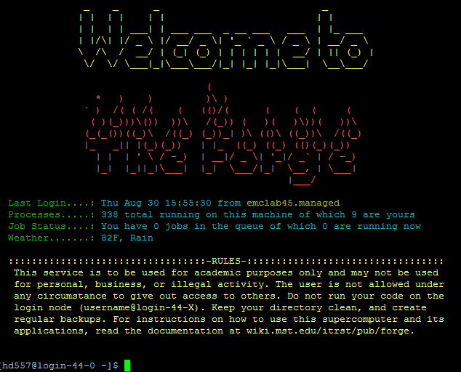
After successful login, Only a basic familiarity with Linux command line is required to use the cluster. For those unfamiliar with this, a very brief tutorial follows. For more advanced features, Google is your friend.

The directory that you are currently in is shown in the command prompt, as seen below. The “~” directory is your “home” directory. The “ls” command lists all files and subdirectories contained in your current directory. To move into a directory, type “cd” (which stands for “current directory”), followed by a space and the name of the directory that you want to move into. This is akin to opening a folder in Windows Explorer. The following figure shows me moving into my “cst_test” directory and listing its contents.
You may notice that there are a lot of files and directories shown in Filezilla that do not appear when you use the ls command. This is because any file in Linux that starts with a “.” is considered hidden in the command line.

5. Create a queuing script
The cluster uses a queuing system that schedules jobs so that they are processed in the order in which they are received. A script needs to be written to add a job to the queue. Once written, this script can be reused very easily. The script is a simple txt file that is placed in the same directory as the .CST file that you want to run. On your local PC, create a txt file in Notepad that contains the following. Text contained within square brackets is meant to be replaced by the user. Note that anything shown below in square brackets requires you to enter the specific information for your model. Do not include any square bracket characters in the final script. Each text line is explained below.

AnsysEM
- Default Version = 17.0
- Also Called Ansys Electronics Desktop
ansysem.sub
#!/bin/bash
#SBATCH --job-name=jobfile.sbatch
#SBATCH --partition=requeue
#SBATCH --ntasks=1
#SBATCH --cpus-per-task=20
#SBATCH --time=01:00:00
#SBATCH --mail-type=BEGIN
#SBATCH --mail-type=END
#SBATCH --mail-type=FAIL
#SBATCH --mail-user=joeminer@mst.edu

module load AnsysEM/17

time ansysedt -ng -batchsolve Model_Cluster_Test_v2.aedt

CST

CST.sub
#!/bin/bash
#SBATCH --job-name=CST_Test
#SBATCH --nodes=1
#SBATCH --ntasks=2
#SBATCH --mem=4000
#SBATCH --partition=cuda
#SBATCH --gres=gpu:2
#SBATCH --time=08:00:00
#SBATCH --mail-type=FAIL
#SBATCH --mail-type=BEGIN
#SBATCH --mail-type=END
#SBATCH --mail-user=joeminer@mst.edu

cst_design_environment /home/userID/path/to/.cst/file/example.cst --r --withgpu=2

The user should edit the several items:
- Job-name
- mail-user
- file address

6. Submit the task

Code: sbatch batch.sub

After finish the mission script, and copy it to the address with the simulation file. Users use the Putty to submit the task.
In FileZilla, it shows like this way:
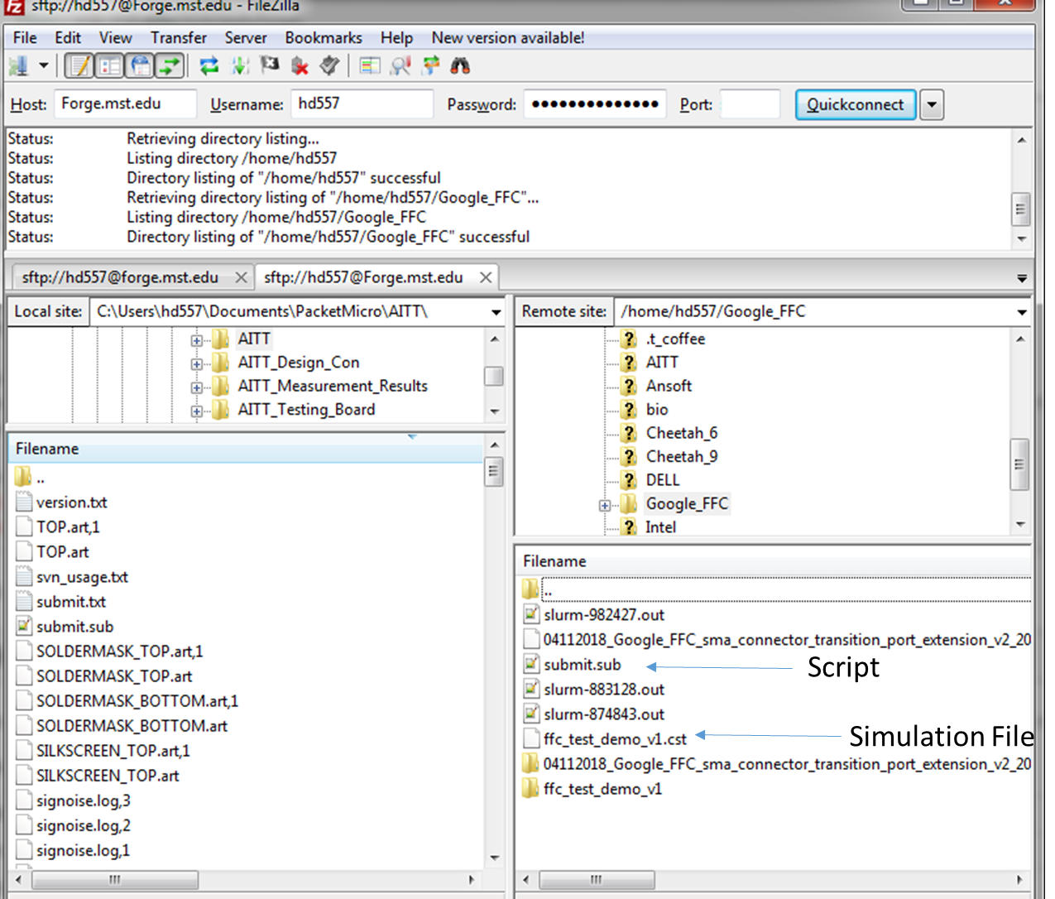
In Putty, user needs to input the code:
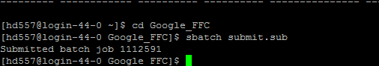
Then, user will receive an email from the cluster
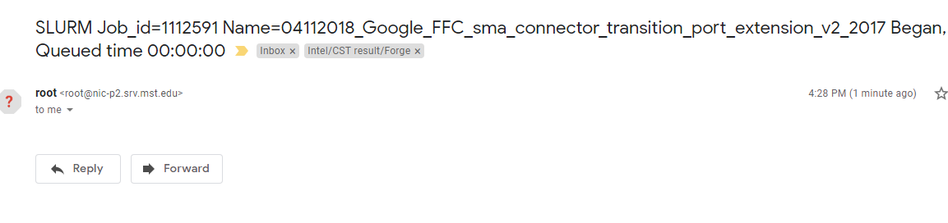
After the simulation, the user will receive the email.
If the model or the script has any issue, use will receive another email.
And user needs to go to the FileZilla and check the log file to figure out what happened.
